Spring 2024

**Airlines System**

Software Engineering

(CSE334s) Group Assignment 2



Presented To

Dr. Islam Al Maddah

**Contents**

THE TEAM’S DETAILS 2

Team Members 2

Introduction 2

Class Diagram 2

Code Test 4

Test 1. List Aircraft Types at Airport 4

Test 2. Find Airports Supporting Boeing 757 4

Test 3. List Airports in France 5

Test 4. Track Aircraft and Flights 5

Appendix 6

Table Of Figures 6

# THE TEAM’S DETAILS

## Team Members

|  |  |
| --- | --- |
| Team Member | ID |
| Mahmoud Abdelraouf Mahmoud | 2001436 |
| Eslam Mohamed Marzouk | 2000252 |
| Ahmed Khaled Abdelmaksod Ebrahim | 2000218 |
| Adham Khaled Abdelmaqsoud | 2000066 |
| Karim Ibrahim Saad Abd-Elrazek | 2001118 |
| Ahmed Mohammed Bakr Ahmed | 2000037 |
| Marwan Wael Mahmoud abbas | 2001244 |
| Somaya Ayman El-Sayed Ahmed | 2000423 |
| Mennatallah Amr Ali Abdel-Motaleb | 2002111 |
| Maya Ahmed Abdullah Ali | 2002124 |

# Introduction

This project represents an exploration into software engineering concepts through the design and implementation of an airline system using Java. As part of our software engineering coursework, we delved into the intricacies of object-oriented programming and system design to develop a robust and functional application that models various aspects of the airline industry. Leveraging Java's versatility and object-oriented paradigm, we constructed a system that encompasses entities such as airlines, countries, airports, fleets of aircraft, and aircraft types, each with their own attributes and relationships.

The implementation code for this project can be accessed at the following link: [GitHub Repository](https://github.com/AhmedBakrXI/Traveller-Planner/tree/master/Assignments/Assignment_2)

# Class Diagram

The class diagram (shown in *Figure 1*) for the airline system consists of several key entities, including Aircraft, AircraftType, Airline, Airport, City, Country, and Fleet. Each class encapsulates specific attributes and behaviors relevant to the airline domain. Aircraft and AircraftType represent the several types of aircraft used by airlines, while Airline encapsulates information about individual airlines, including their fleets and landing arrangements. Airport and City represent geographical locations, with Airport containing information about supported aircraft types. Country acts as a container for cities and airlines operating within its territory. Finally, Fleet represents a specific flight route taken by an aircraft within a given week. The relationships between these classes reflect the associations and dependencies defined in the provided system requirements.

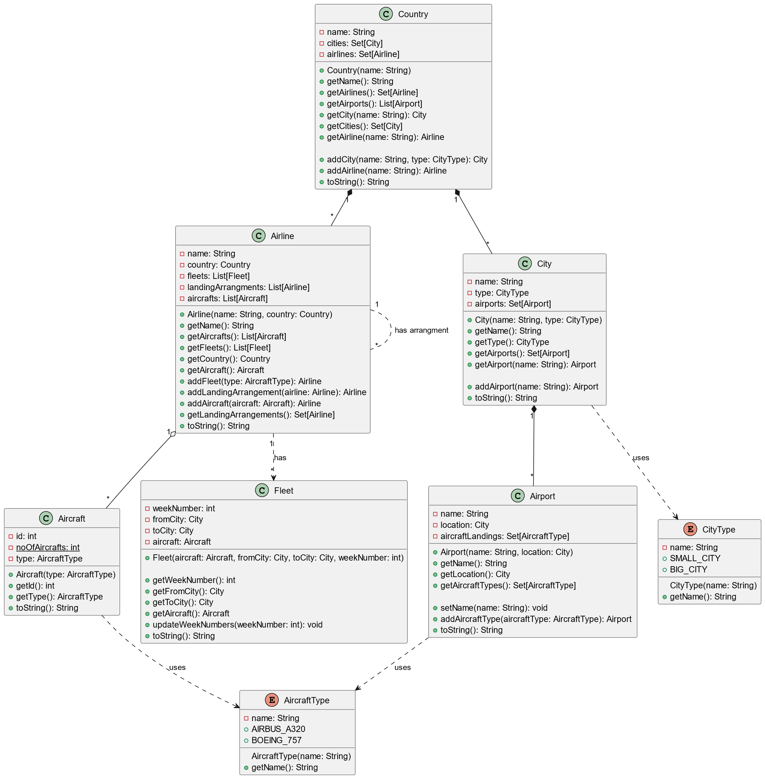

Figure 1: Class Diagram: Modelling an Airline System

# Code Test

## Test 1. List Aircraft Types at Airport

This functionality retrieves an airport object based on its name and location, then accesses its associated set of supported aircraft types. By querying the airport's attributes, specifically the collection of aircraft types it can accommodate, this functionality provides a straightforward approach to listing all aircraft types that are permitted to land at a particular airport. This is achieved by invoking the **getAircraftTypes()** method of the Airport class, which returns a set containing the supported aircraft types. The result is a comprehensive list of aircraft types, facilitating informed decisions for airline operations and airport management. Refer to *Figure 2* for the test result.

Top of Form

## Test 2. Find Airports Supporting Boeing 757

This functionality traverses through the list of countries, cities, and airports to identify all airports across multiple regions that can accommodate a Boeing 757 aircraft type. By iterating over the data structure representing geographical entities, it systematically checks each airport's list of supported aircraft types to determine if the Boeing 757 is present. This search is executed through the **getAirportsSupporting()** method, which takes a list of countries and the target aircraft type as parameters, returning a list of airports that meet the specified criteria. The outcome is a comprehensive compilation of airports capable of accommodating the Boeing 757, facilitating strategic flight planning and logistics for airlines. Refer to *Figure 2* for the test result.

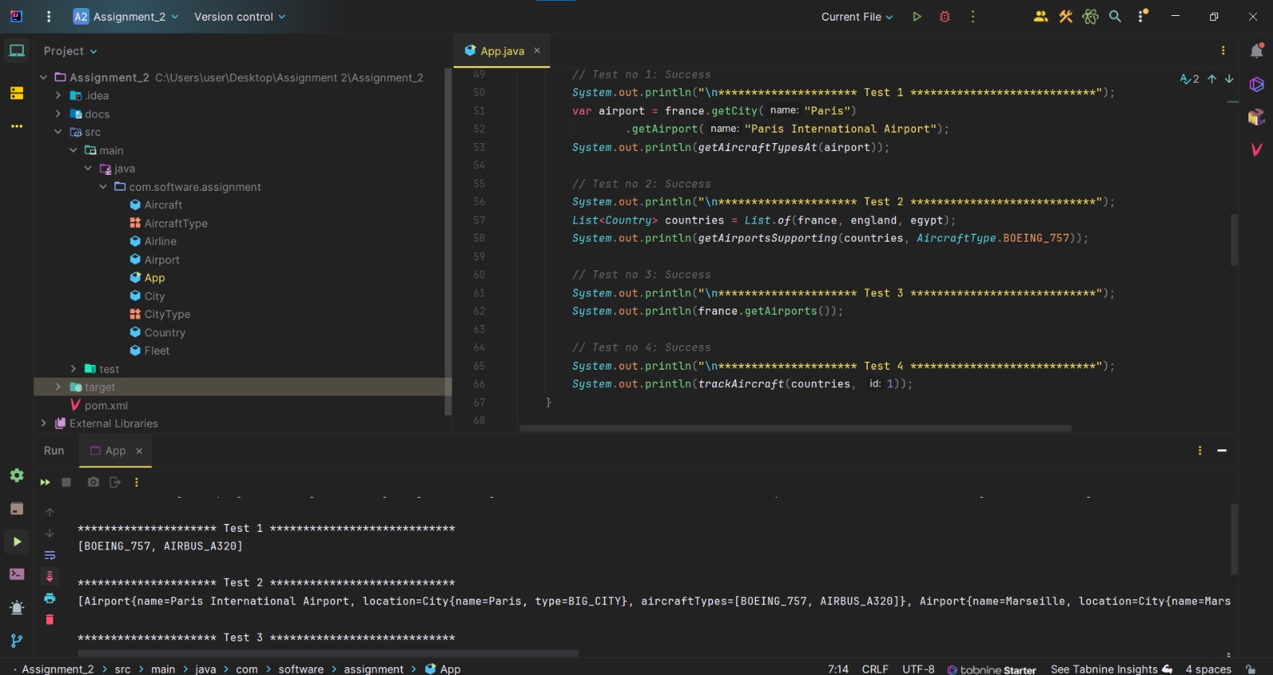

Figure 2: Result of Test Cases 1 and 2

## Test 3. List Airports in France

This functionality leverages the hierarchical structure of countries, cities, and airports to retrieve a list of all airports located within a specific country, in this case, France. By accessing the list of cities within the target country object and subsequently retrieving the airports associated with each city, this functionality systematically assembles a comprehensive catalogue of airports situated within France's borders. The implementation is achieved through the **getAirports()** method of the Country class, which aggregates airports from all cities within the country. The result is a concise inventory of airports in France, essential for facilitating efficient air travel and logistical planning within the country's airspace. Refer to *Figure 3* for the test result.

## Test 4. Track Aircraft and Flights

This functionality facilitates the tracking of a specific aircraft's ownership and its flight history within the last week based on its unique identifier. By iterating through the list of countries and airlines, it searches for the aircraft with the specified ID and retrieves the associated airline. Subsequently, it queries the airline's fleet to identify all flights made by the aircraft within the last week. This process is facilitated by the **trackAircraft()** method, which takes a list of countries and the aircraft ID as parameters, returning detailed information about the aircraft's ownership and recent flight activity. The result is a comprehensive overview of the aircraft's operational history, enabling effective maintenance scheduling and regulatory compliance for airline operators. Refer to *Figure 3* for the test result.

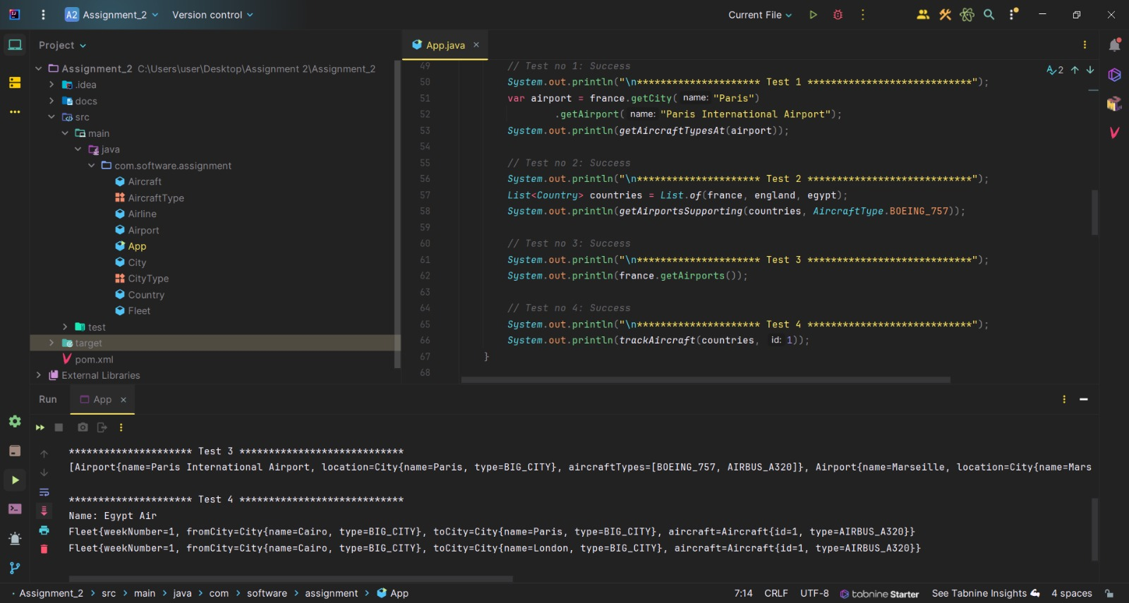

Figure 3: Result of Test Cases 3 and 4

Top of Form

# Appendix

## Table Of Figures

Figure 1: Class Diagram: Modelling an Airline System 3

Figure 2: Result of Test Cases 1 and 2 4

Figure 3: Result of Test Cases 3 and 4 5